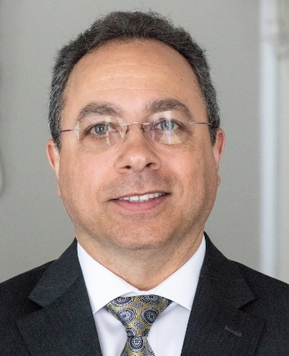
Mark T. Favaloro
Registered Mortgage Broker, NYS Department of Financial Services NMLS 66783

Mark Favaloro is the President of Aamtrust Mortgage, one of oldest and most respected mortgage brokerages in the State of New York. He is also the President of Superior Research LLC, a full-service title insurance company, Affiliated Real Estate Services Group LLC, a commercial-residential property management company and Capital Realty Experts, a residential real estate consulting firm.
Mr. Favaloro is a highly practiced mortgage broker with over 30 years of experience in financing residential properties. He is knowledgeable of the underwriting guidelines for all major lending programs offered throughout the United States by Fannie Mae, Freddie Mac, FHA, VA and USDA. Currently, he serves his mortgage broker colleagues as President of the New York Association of Mortgage Brokers.
Mark also has over 30 years of experience in residential real estate. He is well known by his peers for his vast knowledge of the real estate business and is well respected for his integrity. He was also a Certified Appraiser with the National Association of Real Estate Appraisers and has years of in-depth technical experience in the field of residential real estate valuation.
Throughout his career he has served his real estate community as President of his local Association of Realtors, Member of the Board of Directors of the New York State Association of Realtors, Chairman of his Association’s Professional Standards Committee, Vice President of the Capital Region Multiple Listing Service and Member of the Board of Directors and Northeast Regional President of the New York Association of Mortgage Brokers.
Mr. Favaloro is one of the most dedicated professionals in the field of residential real estate finance. He is known for his quick understanding of complex transactions and his ability to find unique solutions. Currently his offices are located at: 19 Clifton Country Road, Suite 3C Clifton Park, NY 12065. Office telephone: (518) 366-0096 Fax: (518) 207-0345 Email: mfavaloro@aamtrust.com

